Managerial Round Interview Questions

**Sprint Planning**

1. What should be done in particular time frame is called Sprint.
2. Team needs to stay on track always.
3. Team needs capacity, priority and performance to create clear planning to achieve the goal.
4. Very Focused
5. Prioritization
6. Capacity Planning

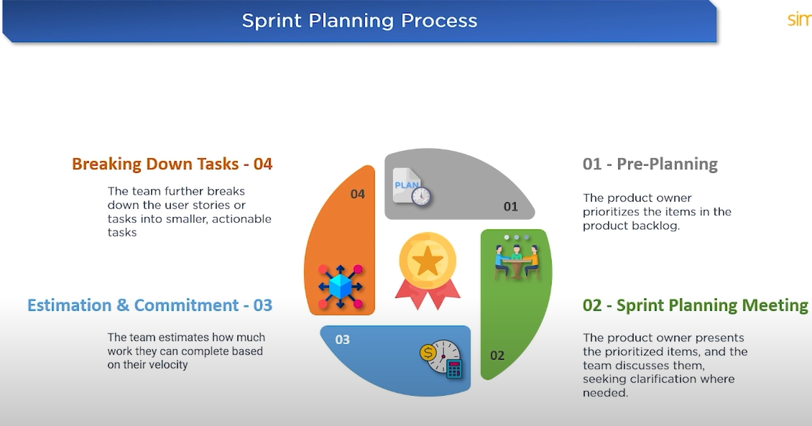

Why you **left your last company**?

Actually, I wanted to grow my Skill

But there is No Java Project in my company

And when last java project was done the I use to do support in that

Then was like 2 to 3 months on bench

What are your **roles and responsibility**?

Do Take care of end-to-end activities with Project

Daily interaction with client because of Client-side project works

Get all reequipments from client

Work on Solutions and Reports to the Manager at the End of the day

Explain your project and how may models are in project?

What Extra you did apart from your regular work?

What SDLC methodology following in your project?

What is different between scrum and sprint?

What is **day to day activities**?

On a typical day, I start by reviewing the code I worked on the previous day and the latest code checkouts.

I attend sprint task meetings and, by the end of the day, report my work and updates, which include client requests and any code changes

What are the tools you have to your project?

How do you track your project?

What are the design patterns are used?

What is cache design pattern?

Requirement changes at las movement?

What will be your 60 days planning if you selected?

How will best fit for this position?

How do you improve your knowledge?

Can you perform under pressure?

What Irritate you about co-works?

Is there any person you cannot work with?

What motivate you at work?

Where do you want see yourself in next 5 years?

How would you Improve upon our product or company?

How would you have criticized by your boss or superior?

What is role in a team?

IF you **make a mistake**, how do you fix it?

Forgot to commit the which I did   
Its very Crucial code and large service class to get an Update

What are some of the workplace successes that you make you proud?

How do you resolve workplace conflicts?

If your team resists your idea, what will you do?

what motivates you at work?

what are your long-term career goals?

Have you ever received recognition for anything?

what are your **strengths and weaknesses?**

**Strength**: - Confident on whatever work am doing.

I always up to make on delivering the products.

**Weakness**: - Definitely I have weakness which is I do overthink

I took extra time to get accuracy in projects

That’s why it will take me the extra work

Do you prefer working on single project or multiple projects at the same time?

What's make you angry?

Situation of difficult time in projects?

How do you **handle your stress?**

Need to Take Break and calm to t situation and start with refresh mind.